**GOVERNMENT ENGINEERING COLLEGE BHARATPUR**



**A Project report on**

**“DESIGN AND IMPLEMENTATION OF A USE OF NATURAL LANGUAGE PROCESSING TO DEVELOP A SYSTEM FOR AUTOMATICALLY TRANSLATING LANGUAGES ”**

SUBMITTED IN PARTIAL FULFILLMENT OF THE REQUIREMENTS FOR THE DEGREE OF BACHELOR OF ENGINEERING IN COMPUTER SCIENCE AND ENGINEERING BY: -

**DEEPAK CHAUDHARY 21EELCSE013**

**AMIT GARG 21EELCSE006**

**ARPIT SAXENA 21EELCSE008**

UNDER THE GUIDENCE OF MR. SUMIT KUMAR

(NETWORK MANAGER)

**DEPARTMENT OF COMPUTER SCIENCE AND ENGINEERING**

**DECLARATION**

We the students of the computer science and engineering from **Government Engineering College Bharatpur** Declare that the work titled with the name **“ DESIGN AND IMPLEMENTATION OF A USE OF NATURAL LANGUAGE PROCESSING TO DEVELOP A SYSTEM FOR AUTOMATICALLY TRANSLATING LANGUAGES ”** has been successfully completed under the guidance of **MR. SUMIT KUMAR** ,of computer science and engineering department ,of government engineering college bharatpur .This is to certify that in partial fulfilment of **B.TECH CSE DEGREE (SEMESTER-4)** examination during the academic year 2023-2024 had not been submitted for any other examination and it does not part of any other course .It is further certified that the project is completed with the all required phases of subject.

**Further we want to tell that the content that we used in this project report has not been submitted previously by anyone for the award of any degree or diploma university**.

**ABSTRACT**

The Language Translator App is a web-based application designed to provide seamless translation services across multiple languages. Built using HTML, CSS, and JavaScript, this app aims to bridge the language barrier and facilitate communication between individuals from different linguistic backgrounds. With a user-friendly interface and intuitive design, it offers a convenient and accessible solution for translation needs.

The core functionality of the Language Translator App lies in its translation engine, which utilizes JavaScript to process and convert text from one language to another. By leveraging the power of modern web technologies, the app can handle a wide range of languages, allowing users to input text in their desired language and obtain accurate translations in real-time.

The app's interface, designed with HTML and CSS, provides a visually appealing and responsive experience across various devices and screen sizes. It offers a simple and intuitive layout, making it easy for users to navigate through different features and options. The user interface also includes input and output text fields, language selection dropdowns, and a clear button to reset the translation.

The Language Translator App employs JavaScript for dynamic functionality such as language detection, translation request handling, and updating the translated text in real-time. By utilizing APIs or language libraries, it can tap into extensive language resources, dictionaries, and machine learning models to enhance translation accuracy and ensure reliable results.

This app serves as a valuable tool for individuals, businesses, and travellers who require quick and accurate translations. Whether it's translating documents, understanding foreign texts, or communicating with people from different cultures, the Language Translator App simplifies the process and promotes effective cross-lingual communication.

In conclusion, the Language Translator App is a versatile web-based application developed using HTML, CSS, and JavaScript. Its user-friendly interface, robust translation engine, and real-time capabilities make it an essential tool for overcoming language barriers and fostering global communication.

**ACKNOWLEDGEMENT**

We like to take this opportunity to express our sincere gratitude and respect to **GOVERNMENT ENGINEERING COLLEGE, BHARATPUR** for providing the platform to pursue my studies and carry out my project.

We have a great pleasure to express my deep sense of gratitude to **Dr. RAVI GUPTA** Sir, principal GEC Bharatpur for his constant encouragement.

We would like to thank **Dr. Prashant Kumar Baheti** sir professor and head, department of computer science and engineering, GEC, bharatpur, who has been a constant support throughout the course of this project.

We consider it a privilege and honour to express my sincere gratitude to my guide Mr. Dhawal Vyas, Associative professor, department of computer science and engineering.

Finally, I would like to thanks my parents and my friends for all the moral support they provided during the completion of this project.

**TABLE OF CONTENTS**

* CERTIFICATE 1
* DECLARATION 2
* ABSTRACT 3
* ACKNOWLEDGEMENT 4
* TABLE OF CONTENTS 5-6
* LIST OF FIGURES 7
* INDIVIDUAL CONTRIBUTION AND REFRENCES 24

|  |  |  |
| --- | --- | --- |
| S.NO | **TOPIC** | **PAGE**  **NO** |
|  | **CHAPTER-1** |  |
|  | **INTRODUCTION** |  |
| 1. | 1.1 PRESENT SYSTEM | 8 |
|  | 1.2 PROPOSED SYTEM | 9 |
|  | 1.3 OBJECTIVE | 10 |
|  | **CHAPTER-2** |  |
|  | **SYSTEM REQUIREMENT AND SPECIFICATION** |  |
| 2 | 2.1 HARDWARE REQUIREMENT | 11 |
|  | 2.2 SOFTWARE SPECIFICATION |  |
|  | **CHAPTER-3** |  |
|  | **SYSTEM ANALYSIS AND DESIGN** |  |
| 3 | 3.1 SYSTEM ARCHITECTURE | 12 |
|  | 3.2 DATA FLOW | 13 |
|  | **CHAPTER-4**  **SOFTWARE DETAILS** |  |
| 4 | 4.1 VS CODE | 14 |
|  | 4.2 GRAPHICAL USER INTERFACE | 15 |
|  | **CHAPTER-5**  **IMPLEMENTATION WORK DETAIL** |  |
|  | **5.1 coding** | 16 |
| 5 | **5.2 designing** | 17 |
|  | **5,3 java scripting** | 17 |
| 6 | **CHAPTER-6**  CODE AND OUTPUT | 18 |
| 7 | **CHAPTER-7**  **CONCLUSION** | 19 |
|  | REFERENCES | 20 |

**LIST OF FIGURES**

* **Fig 1.1 Objectives 10**
* **Fig 3.1 System Architecture 12**
* **Fig 3.2 Data Flow 13**
* **Fig 4.1 Visual Studio Code 14**
* **Fig 4.2 GUI 15**
* **Fig5.1 html code 16**
* **Fig 5.2 CSS code 17**
* **Fig 5.3 java code 18**
* **Fig 6.1 translation 19**

**CHAPTER-1**

**INTRODUCTION**

The Language Translator App is an innovative web-based application developed as part of a college project using HTML, CSS, and JavaScript. This project aims to create a user-friendly and efficient tool that can bridge the gap between different languages and facilitate communication between individuals from diverse linguistic backgrounds.

Language barriers have always posed a significant challenge in our increasingly globalized world. Understanding and being understood by people speaking different languages is essential for effective communication and collaboration. The Language Translator App addresses this challenge by providing a convenient and accessible solution for translating text in real-time.

By leveraging the power of HTML, CSS, and JavaScript, this app offers a seamless user experience with its intuitive interface and responsive design. The HTML structure provides the foundation for the app, ensuring proper organization and layout of the different components. CSS is used to style and enhance the visual appeal of the app, making it visually appealing and user-friendly.

The core functionality of the Language Translator App lies in its JavaScript-based translation engine. JavaScript enables the app to process and convert text from one language to another, utilizing various language resources, APIs, or language libraries. This dynamic programming language enables real-time translation and ensures accurate results for the users.

This college project not only focuses on the technical aspects of building a language translator app but also emphasizes the importance of effective cross-lingual communication in various domains. The project aims to provide a practical solution that can benefit students, professionals, and individuals who interact with different languages on a daily basis.

In conclusion, the Language Translator App developed using HTML, CSS, and JavaScript for this college project seeks to address the language barrier by offering a user-friendly and efficient translation tool. By combining technical expertise with the understanding of the significance of multilingual communication, this project aims to contribute to effective global communication in today's interconnected world.

* 1. **Present System**

Presenting the Language Translator App in HTML, CSS, and JavaScript:

The Language Translator App is a fully functional web-based application built using HTML, CSS, and JavaScript. Its purpose is to provide users with a convenient and efficient tool for translating text between different languages.

HTML: The HTML structure forms the backbone of the Language Translator App. It consists of various elements such as input fields, dropdown menus, buttons, and output containers. These elements are carefully organized and styled to create a user-friendly interface.

CSS: Cascading Style Sheets (CSS) are used to enhance the visual appeal and aesthetics of the Language Translator App. By applying CSS styles, the app achieves a consistent design, responsive layout, and appealing colour schemes. CSS also ensures that the app adapts to different screen sizes and devices, providing a seamless user experience.

JavaScript: The Language Translator App leverages the power of JavaScript for its dynamic functionality. JavaScript is responsible for handling user interactions, such as detecting input changes, capturing user selections, and initiating translation requests. It also facilitates real-time translation updates, ensuring that users can see the translated text instantly.

Translation Engine: The core functionality of the app lies in its translation engine, powered by JavaScript. The translation engine utilizes language libraries, APIs, or machine learning models to convert text from one language to another. JavaScript enables the app to handle complex algorithms and seamlessly process translation requests, delivering accurate results.

User Experience: The Language Translator App prioritizes user experience by providing a clean and intuitive interface. Users can input text in their desired language, select the source and target languages from dropdown menus, and initiate the translation process with a click of a button. The translated text is displayed in real-time, allowing users to communicate effectively across language barriers.

Accessibility: The app is designed to be accessible to a wide range of users. It adheres to web accessibility standards, ensuring that users with disabilities can navigate and utilize its features with ease. Additionally, the app supports multiple languages, enabling users to translate text from and to various language options.

* 1. **Proposed system**

Our proposed Language Translator App is a web-based application that aims to provide seamless translation services across multiple languages. Built using HTML, CSS, and JavaScript, this app is designed to offer a user-friendly interface and efficient translation capabilities.

Key Features:

1. User-friendly Interface: The app will have a clean and intuitive user interface, allowing users to easily input text and select the desired source and target languages for translation.

2. Language Selection: The app will provide a dropdown menu or a list of languages from which users can select the source and target languages. This will enable them to translate text from one language to another with ease.

3. Real-time Translation: The translation engine will utilize JavaScript to process and convert text from the source language to the target language in real-time. As users type or paste the text, the translation will be instantly displayed, providing immediate results.

4. Language Detection: The app will incorporate language detection functionality, automatically identifying the source language if the user is unsure or does not specify it. This will enhance the user experience and eliminate the need for manual language selection in some cases.

5. Responsive Design: The app will be designed using HTML and CSS to ensure a responsive layout that adapts to different screen sizes and devices. This will enable users to access and utilize the app seamlessly on desktops, laptops, tablets, and smartphones.

6. Translation Accuracy: The app will utilize reliable language resources, APIs, or language libraries to ensure accurate translations. By leveraging established translation services or incorporating machine learning models, the app will strive for high-quality and precise translation results.

7. Clear and Reset Options: The app will provide a clear button or reset functionality to allow users to easily remove the input text and start a new translation session without any hassle.

* 1. **Objective:**

FIG 1.1 Objectives

**CHAPTER-2**

**SYSTEM REQUIRMENT AND SPECIFICATIONS**

This chapter involve both the hardware and software requirements needed for the project and detailed explanation of the specifications**.**

**2.1 Hardware Requirements**

1. A PC with Windows /Linux Operating System
2. Processor with 1.7GHZ or more speed
3. Minimum 2 GB RAM
4. Minimum 128 GB SSD **/** 512 GB HDD
   1. **Software Specifications**
5. Text Editor (vs-code/ web storm/ notepad++)
6. **JDK** (java development kit)
7. **JavaScript**
8. **CSS**
9. **HTML**
10. We need VS-Code (Easy Editor)

**CHAPTER-3**

**SYSTEM ANALYSIS AND DESIGN**

In this chapter we will discuss about the system architecture how the process is running and the data flow of system though pictorial representation.

**3.1 System architecture**

**Input the**

**text**

**user**

**Language selection**



**API CALLS**

**Live translation**

**Translated to other language**

**BACKEND process**

FIG 3.1 SYSTEM ARCHITECTURE

**3.2 Data flow**

**FIG 3.2 Data flow**

**CHAPTER-4**

**SOFTWARE DETAILS**

**4.1 VS Code**

It is an IDE i.e., Integrated Development Environment which has many features like it supports scientific tools (like matplotlib, NumPy, SciPy etc) web frameworks (example Django, web2py and Flask) refactoring in Python, integrated python debugger, code completion, code and project navigation etc. It also provides Data Science when used with Anaconda.

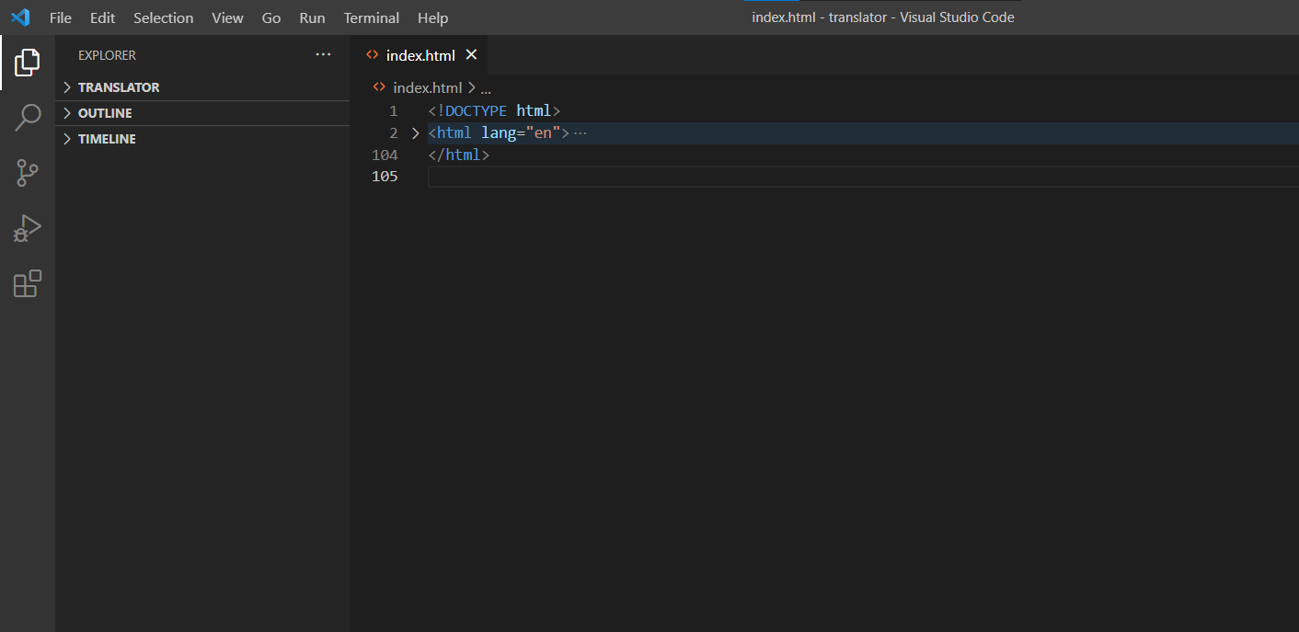

FIG 4.1 VISUAL STUDIO CODE

**4.2 Graphical user interface (GUI)**

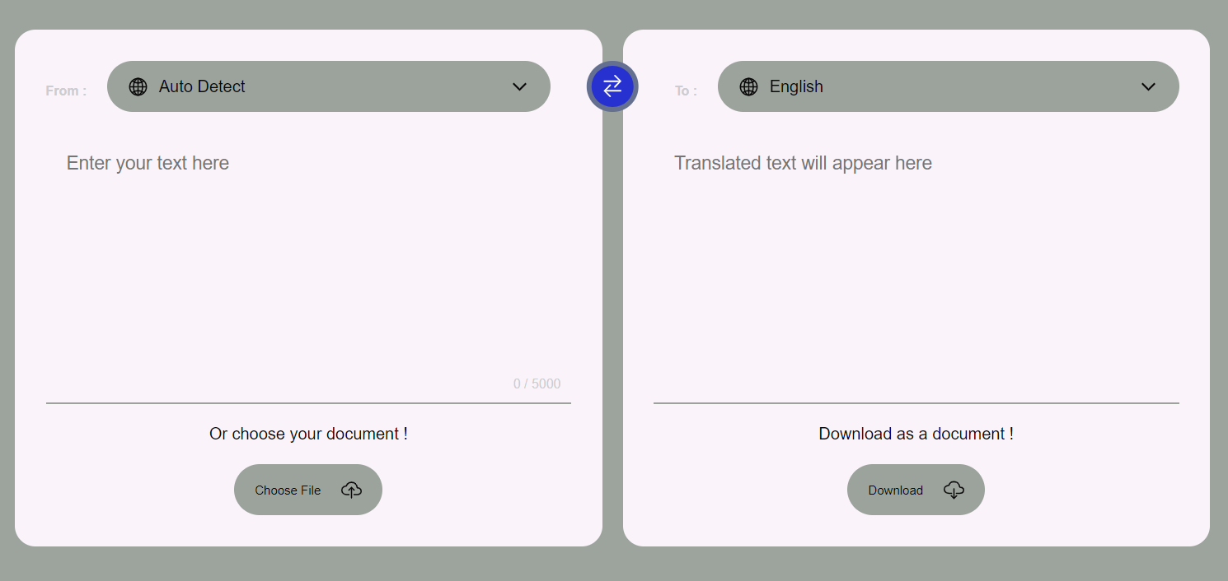

Fig 4.2.1 GUI Interface (Light theme)

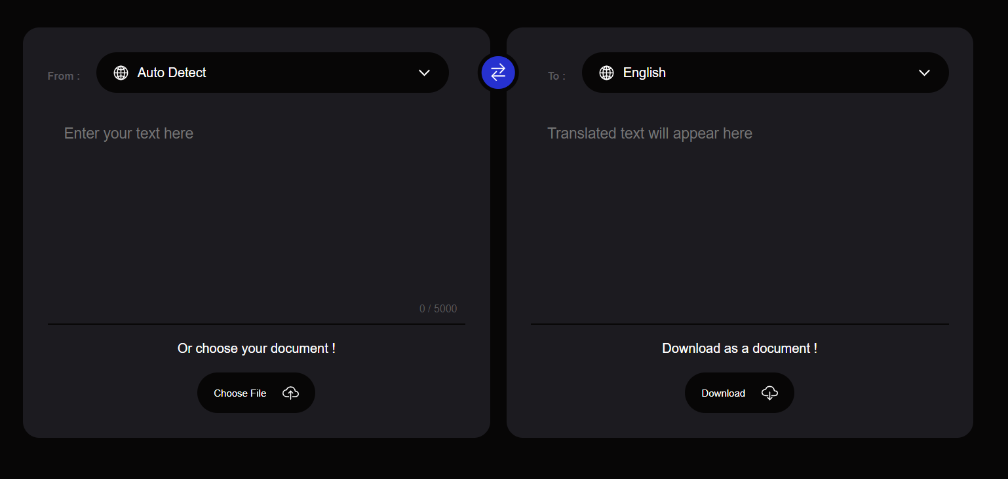

Fig 4.2.2 GUI Interface 2 (Dark theme)

**CHAPTER-5**

**MPLEMENTATION WORK DETAIL**

**5.1 Coding**

In this we use simple line of HTML code lines such as:

* Div

It is a tag consider as a section or division in HTML File. It used as a container.

It uses along with class or id attributes.

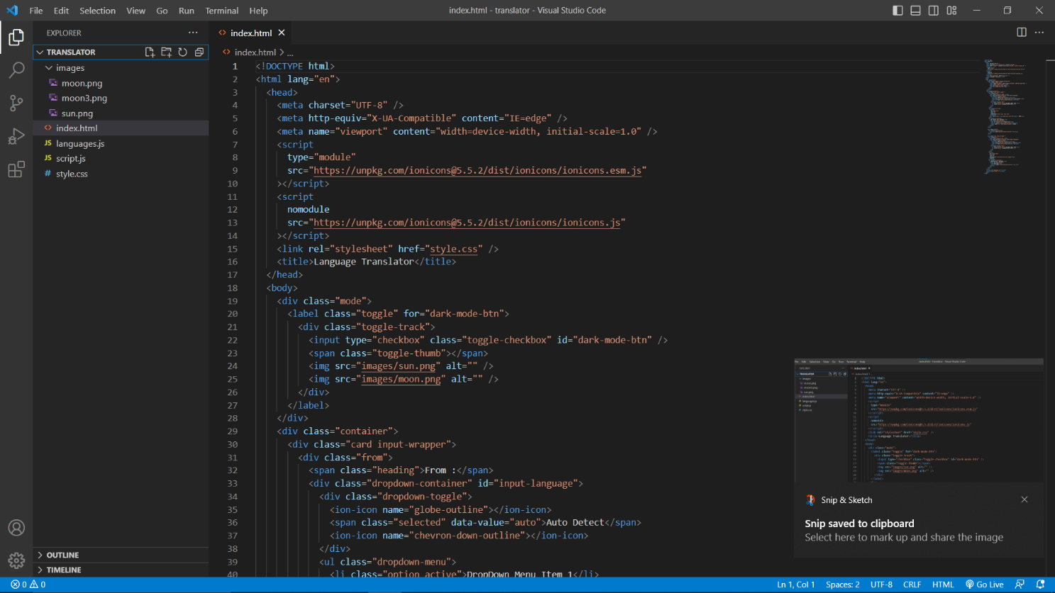

Fig 5.1 HTML Code

5.2 Designing

* CSS

For styling, Designing the web page to look more attractive, feasible to study.

We use cascading style sheet; it is line of codes which uses to design text format

design, colour, background colour, margin & padding or many other stylings is to be

done.

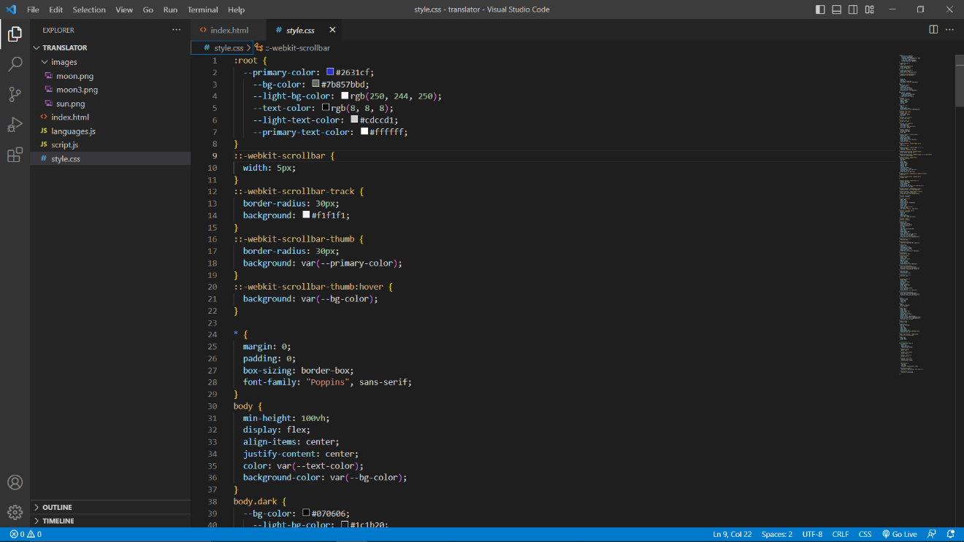

Fig 5.2 CSS Code

5.3 Java Scripting

It is a scripting which implements additional features on web page.

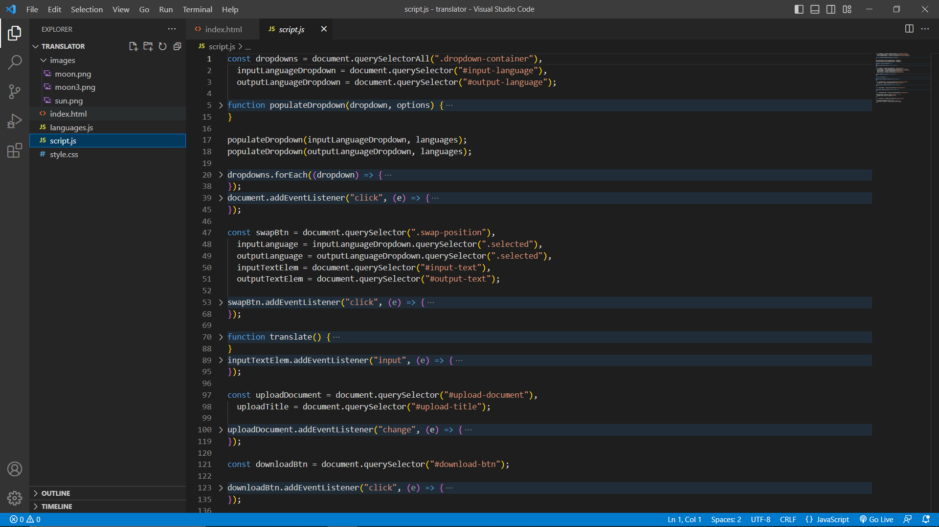

Fig 5.3 Java Script

**CHAPTER-6**

**OUTPUT OF CODE**

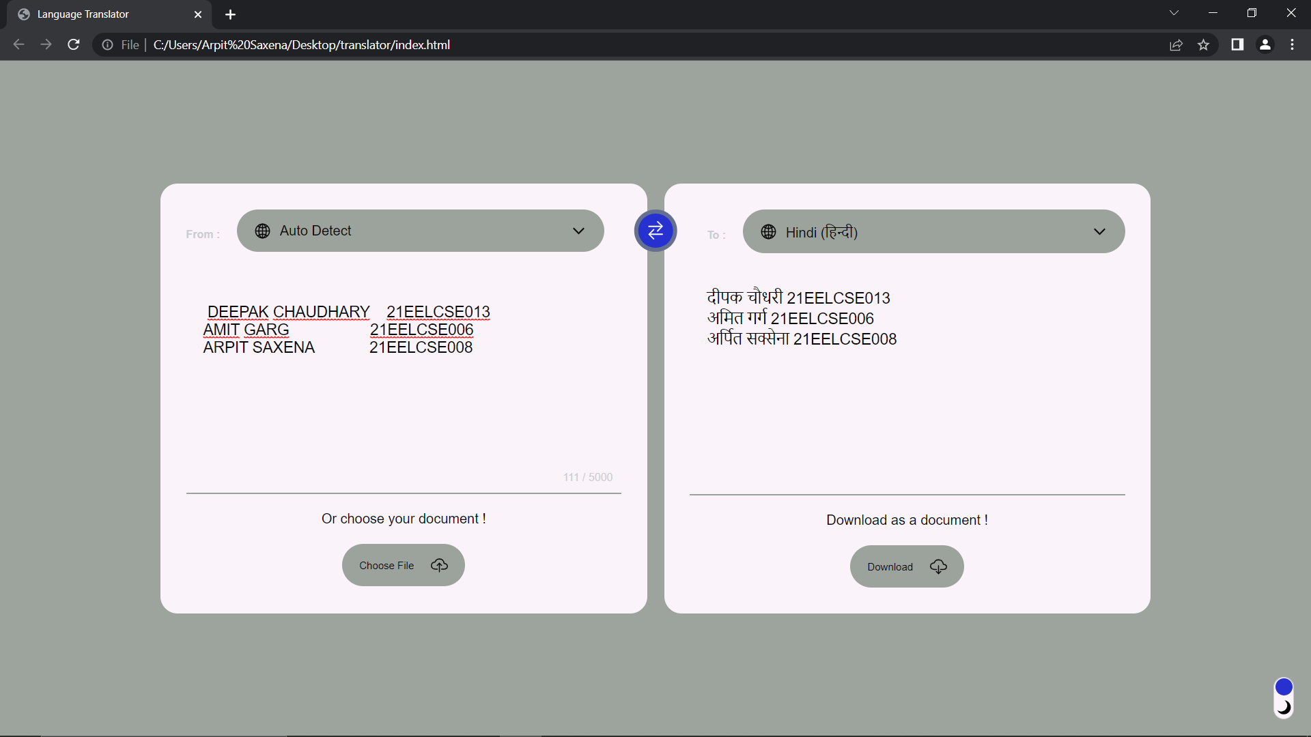

Fig 6.1 Translation

**CHAPTER 7**

**CONCLUSION**

Our proposed Language Translator App, developed using HTML, CSS, and JavaScript, aims to provide users with a user-friendly and efficient translation experience. By combining responsive design, real-time translation capabilities, and accurate language processing, this app seeks to break down language barriers and facilitate effective communication between individuals from different linguistic backgrounds. forecast, it gives desktop reminders of your choice. It can have some basic conversation.

**Limitations :**

1. It only works over internet connection.

2. Verbal translation not to be implemented.

**Scope for future work :**

1. Used as E-Guide , It helps the tourist by translate the local language just by using

this translator.

2. It changes any language to its local primitive language. (User-Friendly)

**INDIVIDUAL CONTRIBUTION**

In this project all three of us distributed our work as per the conditions and knowledge so the work done by individual is as follows:

**Amit Garg:** Design the code Program.

**Arpit Saxena:**  Design web template and report file.

**Deepak Chaudhary:** Design innovative presentation ideas with Report File also.

All of us give our best to design and implementation of a use of natural language processing to develop a system for automatically translating languages along with report file.

We co-ordinate with each other in making this project successfully completed.

Thank you

**REFERENCES**

* GitHub
* W3school
* JavaScript repositories